Form1: In the below Form user can enter a location and select applicable parameters for those locations via check boxes. For example for Location 07 Header (row 1 in form) only Grav, Methanol and Avg BHP values are checked. So once the form is submitted the corresponding Location gets entered into SQL server table (say table 1) shown in right (Applicable parameters will have value 1 and not applicable parameters will have value NULL)
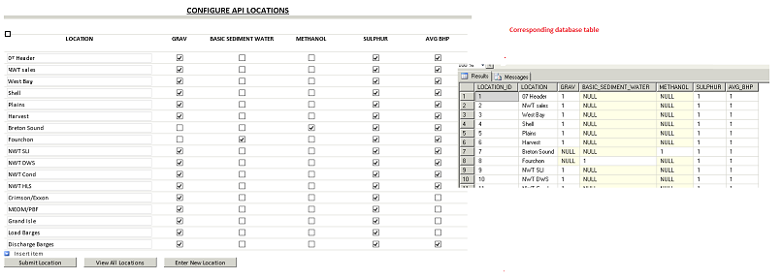
Form 2: form2 will show the Location that we configured in Form1 via a dropdown list box and the applicable parameters as text box, here users can submit the values of parameters. The submitted values will be saved in a SQL server table (Say table 2, shown in right).
My first requirement: The value that is greyed in below form, should be grayed dynamically based on the values that we configured in Form 1/Table1. For Example for Location 07 Header, if you see Form1 S&W and Methanol is unchecked/Null. So in form2 it should be dynamically greyed out and users should not be able to enter the values. (Currently I have done this in form2 for each location manually)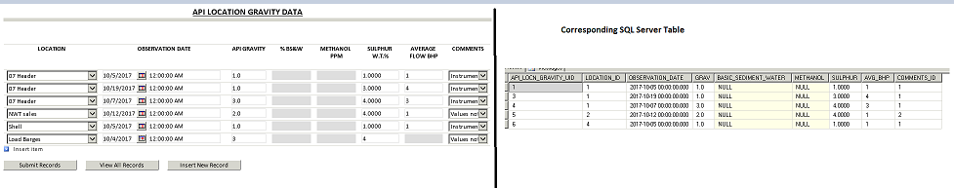
Requirement 2: This requirement is also in Form2. Users need 5 comment boxes at the end of each parameter as shown below in red text. 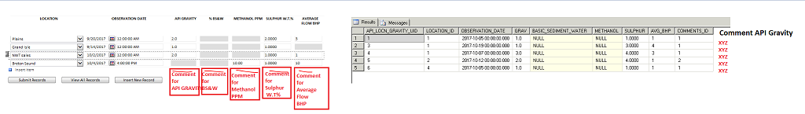
On click of submit, data should be saves in DB corresponding to each location. in the table2. Table 2 will have 5 new columns for each comment
For example if user enters comment in comment box for API Gravity as "XYZ" then in Table2 I will add one more column Comment API Gravity and that XYZ should be shown for All 5 locations as shown below (right hand side.)
Requirement 3: Using the same table and columns shown in step 2/ Table2. I want to create a form that should look something like this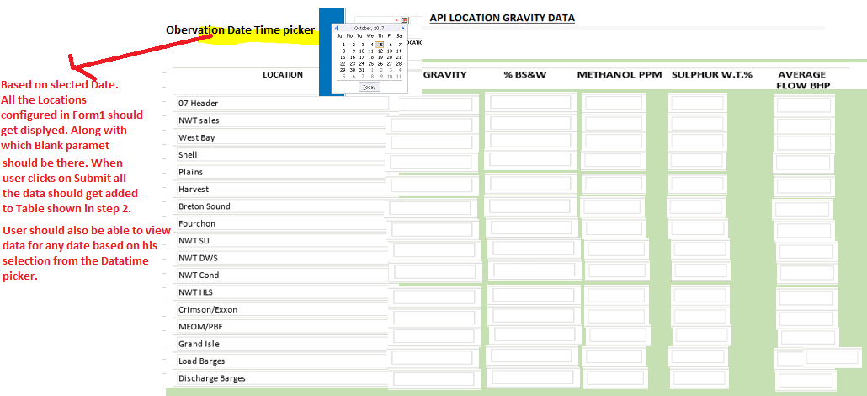

Thanks & Regards,
Preeti

