Create a data connection:
- Create a receive data connection to your SharePoint list
- Select the drop down list which you want to link to the SharePoint list->Right click ->Click Drop-Down List Box Properties
- Select “Get choices from an external data source”
- Select the data source that you just created
- Click the XPath for Value
- Click the XPath of Display Name

Add the following Rule to the drop down field:
- Set a fields value(queryFields->Name) to the value from the dropdown:
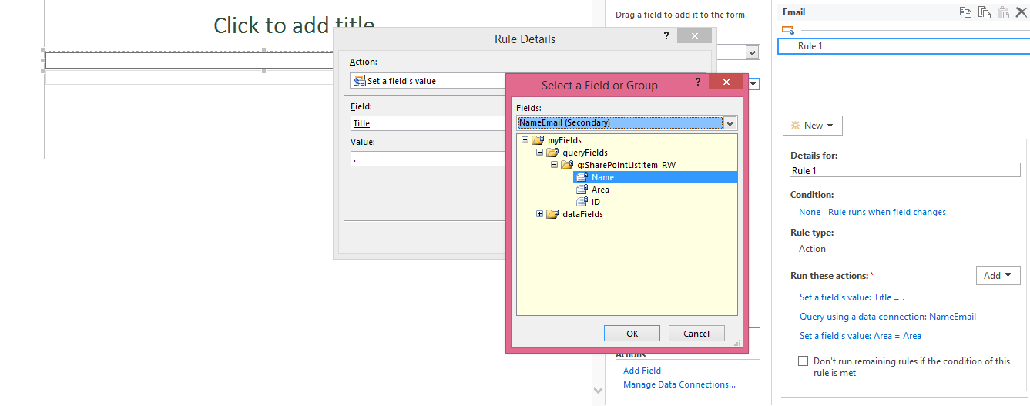
- Query the secondary Data Source
- Set the text fields value to value from the secondary data source

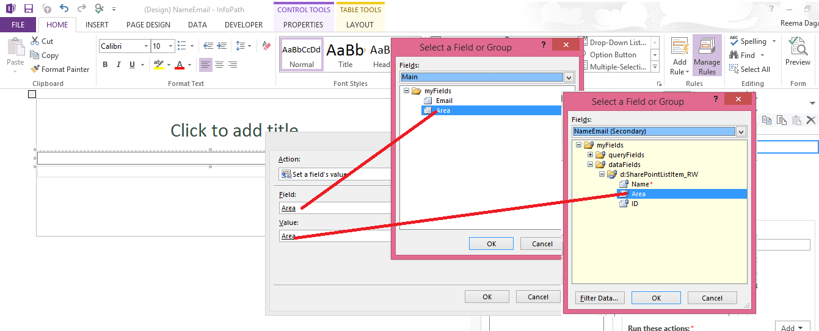

- Your rule should look like this:
