Submitting a Managed Metadata to a SharePoint List

qRules v5.1 allows us to query a SharePoint Managed Metadata to our InfoPath forms. In this document we will explain how to submit a SharePoint TermSet to a SharePoint List using qRules.

The Issue
When a Managed Metadata is queried to a drop-down list, it gives us a Term Name. However, if we try to submit this data to a SharePoint column, we get a different value from the drop-down list as shown below.
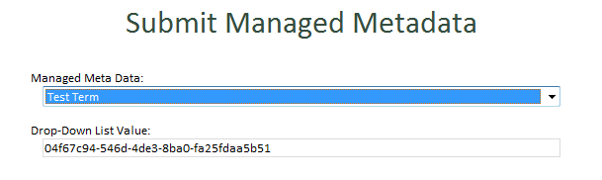
This data needs to be submitted in a particular format to successfully set the value in the column.
The Format:
-1;#TermName|TermGUID
Example:
-1;#TERMNAME|29d68905-107b-4aa1-aefb-e93ae8f53bfe

Solution
To get this value, let us first create a field which will submit the specific value to a SharePoint column and let’s name it ManagedMetadataSubmit.
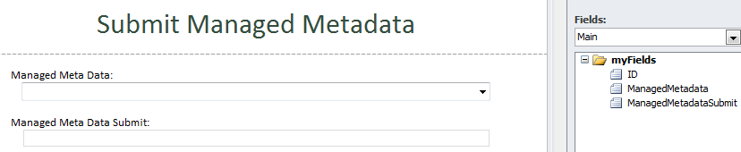
Next, create a rule for the ManagedMetadata field that sets the value of ManagedMetadataSubmit whenever a TermName is selected. We will let this field generate a Value with a format SharePoint recognizes.
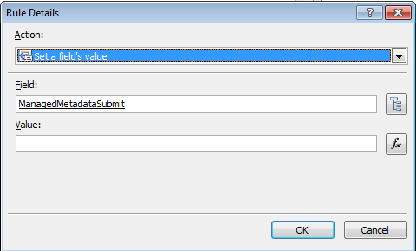
Click the fx button and insert a concat formula which will combine the three values.
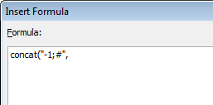
-1# enclosed with quotation marks is the WSS ID value of the taxonomy term for SharePoint
The next value for the concat formula is the Term Name which we will extract from QdabraRules_TermSets Secondary source:
Click Insert Field or Group selection and select the a32 node
/ns1:QdabraRulesTermSets/ns1:GetTermSets/tns:Container/tns:TermStore/tns:T/tns:LS/tns:TL/@a32
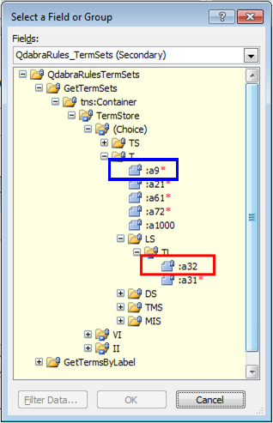
Filter the data on the condition that the a9 node is equal to the field ManagedMetadata of the Main source.
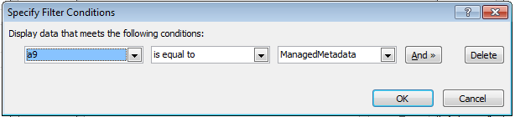
In between the second and third value is a Vertical Bar which needs to be declared, enclosed with quotation marks, and separated by commas.
Lastly, insert the Term GUID by using the field or group selection button and select ManagedMedata (this will be represented by a dot).
Here is how the rule should look like:
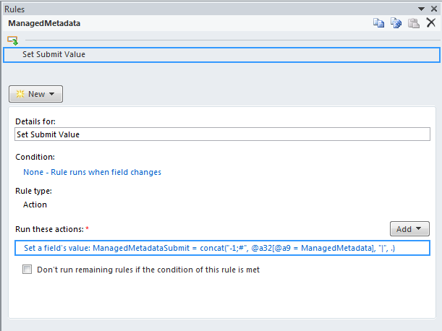
Formula:
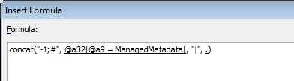
SharePoint Column
We now have a field that generates the specific format which a SharePoint List can identify.
Before we submit this format, let’s make sure that the column receiving the Managed Metadata is synchronized with the type of data we are submitting.
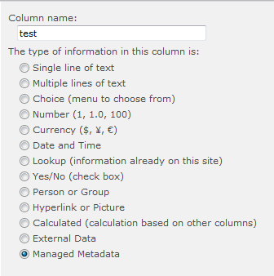
Configure the Term Set Settings by selecting the appropriate term set as indicated on the diagram below.
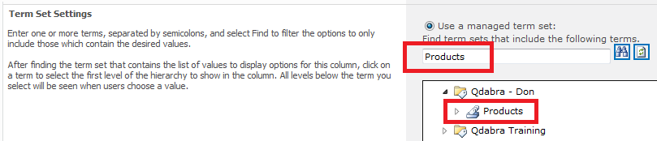
Click OK to save this column at the SharePoint List.
Launch the SharePoint List Tool and map the ManagedMetadataSubmit field to a SharePoint Column with Managed Metadata settings.
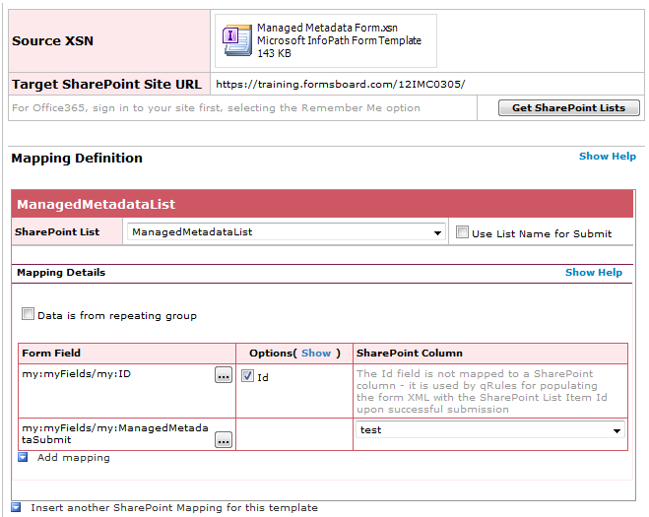
Be sure to indicate the ID field by clicking (Show) and tick checkbox.
Save… and add this mapping to the form as a Data Connection which receives data as an XML document.
**If the file has been saved under a different name other than the default “mapping” name, take note of the exact “MappInG1234” name so that we can declare the mapping connection properly upon submitting the form later on.

At Data Connections, add a connection which will allow us to submit data using the UpdateListItems operation of the SharePoint Lists web service. That web service URL should like this:
http://myserver/site/_vti_bin/lists.asmx?WSDL

With "myserver/site/" replaced with the actual SharePoint site URL.
With qRules v5.1, we no longer have to select any values for the parameters - InfoPath will display a warning, but we can safely ignore it:

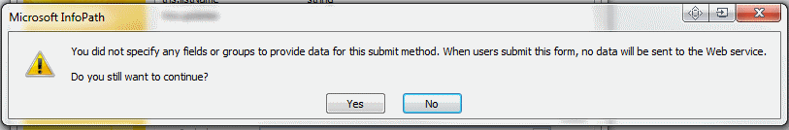

qRules will set the input parameters for you when you execute the command. Click "Yes" on this warning dialog and finish creating the connection using an identifiable name such as “ShPListSubmit “.
Since the form is able to query a Managed Metadata, it is safe to assume that the form has already been pre-injected with qRules with the Term Set APIs included.

Submit Button

Let’s recall that a new item gets created every time we select a Term on the drop-down list - the Managed Metadata column will get populated when this item is updated. Therefore we would need to add a submit button that performs a Double Submit when the button is clicked.

Click the submit button, and add a rule at the properties tab which will set a field’s value when the button is clicked.
For Field, let’s use Command of the QdabraRules Secondary source:

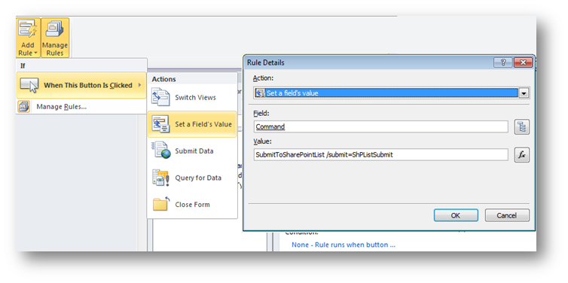
Set the value:
SubmitToSharePointList /submit= ShPListSubmit
Make sure that the Data Connection name is saved in the same manner as it was written on the value for command.
Note:
If the mapping connection has been saved under a different name other than the default “mapping” name, we would need to declare this parameter, otherwise omit this procedure.
SubmitToSharePointList /submit= ShPListSubmit /mapping= MappInG1234
Both are CaSe SENsiTivE.

Add another action to the Submit Button rule which will perform the same task of submitting to ShPListSubmit.
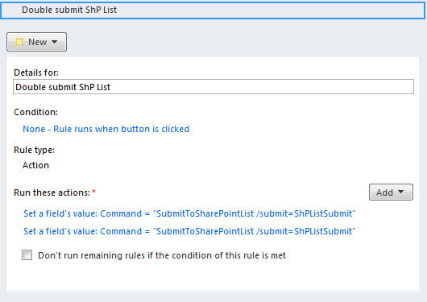

Test the Form
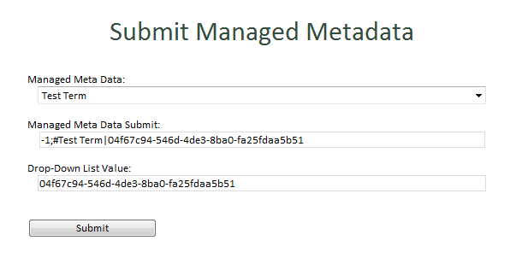
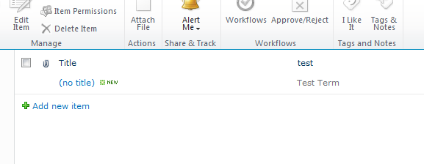
We have now successfully submitted a Managed Metadata “Term Name” to a SharePoint List.

