Cascading Drop downs – populates from data retrieved from a data source
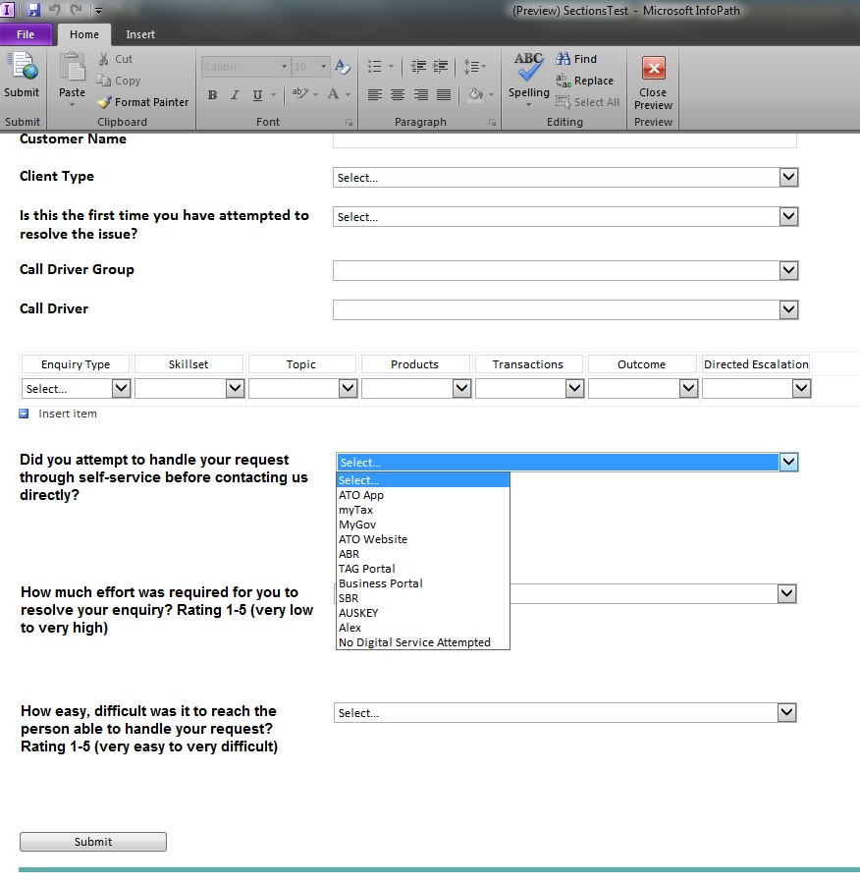

These fields are hidden until a selection is made in the ‘Did you attempt to handle your request through….’ Once a selection is made they appear as seen here.
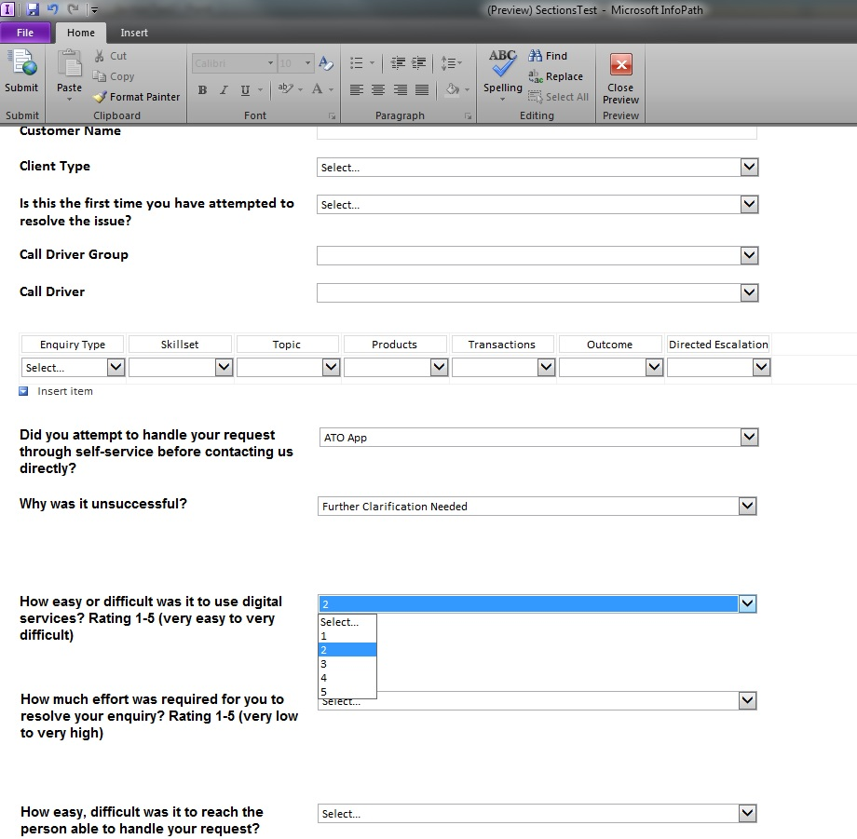

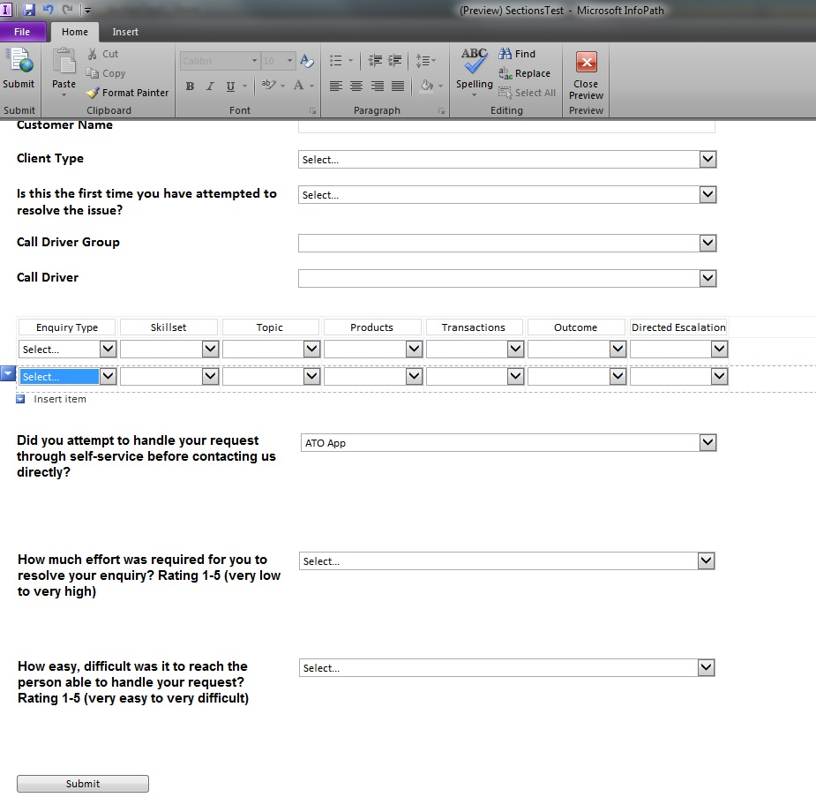
Fields are gone
Once a call operator inserts a new row for a subsequent enquiry, the fields that appeared in the previous step now disappear. However the selection in the ‘Did you attempt to handle your request…’ is still clearly visible.

