DBXL 2.6 VS 2.9
This document is a comparison of the public web services available with Qdabra DBXL Version 2.6 and Version 2.9

Requirements
This lab requires a SharePoint library that has a bunch of submitted Expense Report forms. In Part 9, you created an Expense Report library and configured it to use a content type with a reusable workflow that creates list items into a SharePoint list called “Workflow_Metrics”. You may use the same objects for this lab.

Add Rules that Retrieve Submitted Forms
When the Dashboard opens, we would like it to display a list of all Expense Reports that have not been approved yet; and then we’ll add some color coding on these items to indicate how long ago they’ve been submitted so that the users know which ones to pay more attention to.
The Dashboard will pull items from your Expense Report library using OData so that we can filter data and return only the non-approved items.
- In InfoPath Designer, open the starter template included in this lab – named “Expense Reports Dashboard – Start.xsn”.
- If you go to Data > Data Connections and look at the one named “SubmittedExpenses”, you will see that it retrieves data using the REST web service.
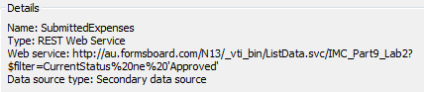
The REST web service URL is set to pull items from our test library called IMC_Part9_Lab2, filtered so that it only returns items where the CurrentStatus node is not equal to “Approved”. We will change this URL via rules.
- Go to Data > Form Load and add a new action rule. The first action changes the REST URL of the SubmittedExpenses data connection.
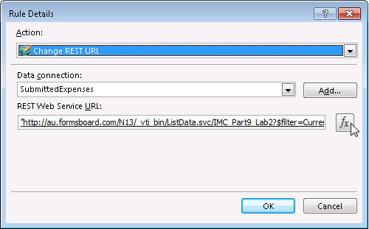
- Click on the fx button next to the URL and change it to connect to your own site’s Expense Reports library. e.g. http://au.formsboard.com/<YourSite>/_vti_bin/ListData.svc/<YourExpenseReportsLibrary>?$filter=CurrentStatus ne 'Approved'
- The next action in the same rule will query the data connection.
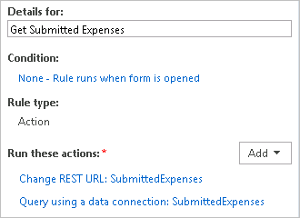

Add Status Indicators
Next, we will add some conditional formatting to highlight the rows based on how long each Expense Report has been submitted; i.e. how long they’ve been sitting in the library waiting for approval.
We will use the following color coding:
- Green – if the form has been submitted 2 minutes ago
- Yellow – the form has been submitted 4 minutes ago
- Orange – the form has been submitted for more than 8 minutes

- Select the first section that you see on the form canvas:
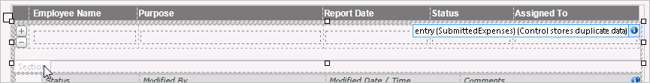
- In the Rules pane, add a new formatting rule. The first rule will highlight the section with color orange, meaning the form has been submitted for more than 8 minutes.
  - Click “None” to display the Condition window.
  - Change the first dropdown to The expression
  - Copy/paste this formula replacing the default expression: translate(xdDate:AddSeconds(m:properties/ns2:Modified, 8 * 60), "T-:", "") < translate(xdDate:Now(), "T-:", "")
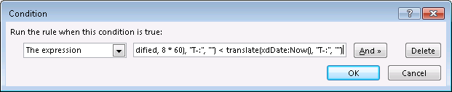
Everything before the “<” sign of the formula – what it does is it adds 480 seconds to the value of the Modified node, and then removes the texts “T”, “-“ and “;” using the translate() function. So if for example, the XML value of Modified = 2013-06-13T00:00:00, it will be converted to 20130613000800. The rest of the formula simply removes the texts from the current date and time, leaving just the numbers. The entire expression basically checks if the Modified date/time has passed 8 minutes (or more) from the date/time now.
  - For the shading, select the color orange (or lighter so it’s more pleasing to the eye).
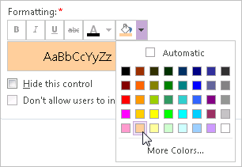
- Add a second formatting rule that highlights the section with the color yellow if this condition is met: translate(xdDate:AddSeconds(m:properties/ns2:Modified, 4 * 60), "T-:", "") < translate(xdDate:Now(), "T-:", "")
- Finally add one for green using this condition: translate(xdDate:AddSeconds(m:properties/ns2:Modified, 2 * 60), "T-:", "") < translate(xdDate:Now(), "T-:", "")

Configure the Hide-Show Assignment History Section
Notice the Expand and Collapse picture buttons that we have pre-added in the starter template – you will add rules and conditional formatting to these buttons to hide and show the Assignment History section which is pulled from the Workflow_Metrics list in SharePoint. Recall that in the past lab, you have configured a reusable workflow to submit data from the Expense Report forms into this list for assignment and email notifications.
We will first update the data connection in the Dashboard form to retrieve items from your own instance of the Worklfow_Metrics list.
- Go to Data > Data Connections and modify the one named Workflow_Metrics – walk through the wizard specifying your own site URL and selecting your own list.
We will now update the picture buttons to retrieve the items and show the list data in the Assignment History section.
- Select the Expand picture button on the canvas.
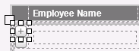
- Add a new action rule named ‘Get History’ that does the following:
  - Set a field’s value where Field is the queryFields Title node of the Workflow_Metrics secondary data source:
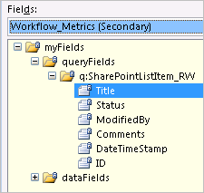
…and Value is the Name node of the SubmittedExpenses secondary data source:
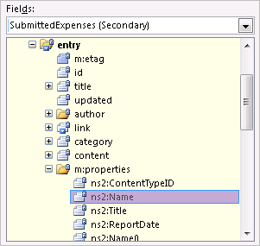
  - Next, add a second action that queries the Workflow_Metrics data connection.
Our rule should look like this:
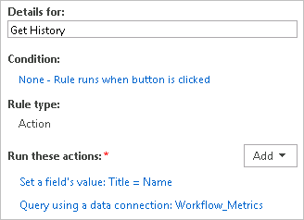
We are basically telling our button to filter the query to only return the list items that have Title equal to the form name in the current context.
- Add another action rule that shows the history section – set a field’s value where Field is any node that is a child of the parent ‘entry’ node. You can use a field that is not being used to display data in your Dashboard form – let’s use the content node.
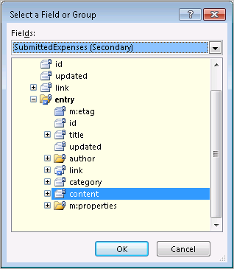
We’ll set its Value to show.
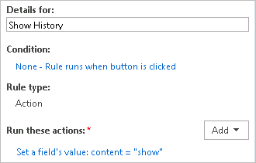
The purpose of this is so that we can add a conditional formatting on our history section to hide if content is not equal to ‘show’ – but we’ll get to that later. Let’s finish up the Expand button rules first…
- Add a new formatting rule to the Expand button that hides it if we are already showing the history of the current Expense Report item, i.e. the button has been clicked.
- Click “None” to display the Condition window.
- Change the first dropdown to The expression
- Copy/paste this formula replacing the default expression:
ns3:content = "show" and m:properties/ns2:Name = xdXDocument:GetDOM("Workflow_Metrics")/dfs:myFields/dfs:queryFields/q:SharePointListItem_RW/q:Title
- Click OK. You should now have this condition:
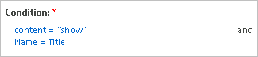
- Next, we’ll add a rule to the Collapse button to hide the history section on click – so set a field’s value where Field is same content node that we’ve been setting in the previous steps; set it to the Value ‘hide’.
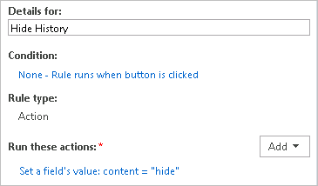
- We’ll then add conditional formatting to the Collapse button so that it’s hidden until we have expanded the history section, i.e. we have not clicked on the Expand button yet; and also if what’s being collapsed is not actually the history for the current Expense Report item. So we’ll have two conditions that hide the button (add these as expressions):
  - ns3:content != “show”
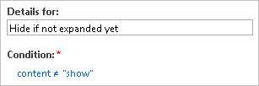
  - m:properties/ns2:Name != xdXDocument:GetDOM(“Workflow_Metrics”)/dfs:myFields/dfs:queryFields/q:SharePointListItem_RW/q:Title
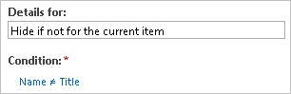
- Next, we’ll add conditional formatting to the history section itself.
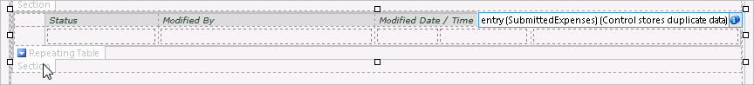
The section will be hidden the same way as we’re hiding the Collapse button so copy those two formatting rules and paste them in the Rules pane with the section selected on the canvas.
In the next section, we will create a SharePoint page that displays only the Dashboard. In order to make the Dashboard appear like it’s an actual web page and not an InfoPath form, we will first remove the InfoPath ribbon.
- Go to File > Form Options; under Web Browser, uncheck the box that says ‘Show InfoPath Commands in Ribbon or toolbar’, and then click OK.
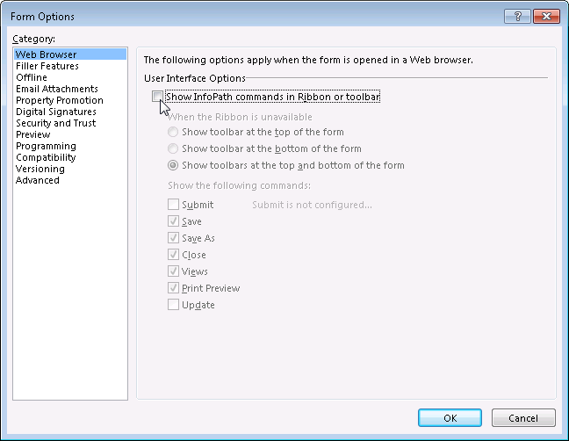
We’re done designing our Dashboard! You can test your form in Preview mode; although the tables will show as if they’re not properly aligned, they should look nice in the browser.
When you’re satisfied with everything and you’ve verified the functionalities, you can go ahead and publish the Dashboard to your site on a new library, or even as a content type.

Create a Web part page
We will now create a SharePoint page that displays the Expense Report Dashboard form using a web part.
- Go to your SharePoint site, go to Site Actions > View All Site Content > Create.
- Under Filter By:, select Page > Web Part Page and then click Create
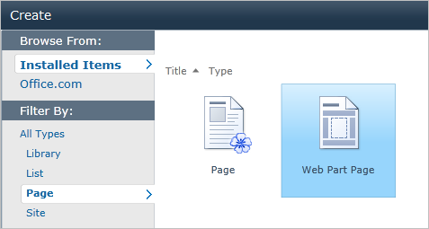
- Name your web part page and select a layout type. You’ll need to associate the web part page with a document library, so pick the one where you published your Expense Report Dashboard to; and then click Create.

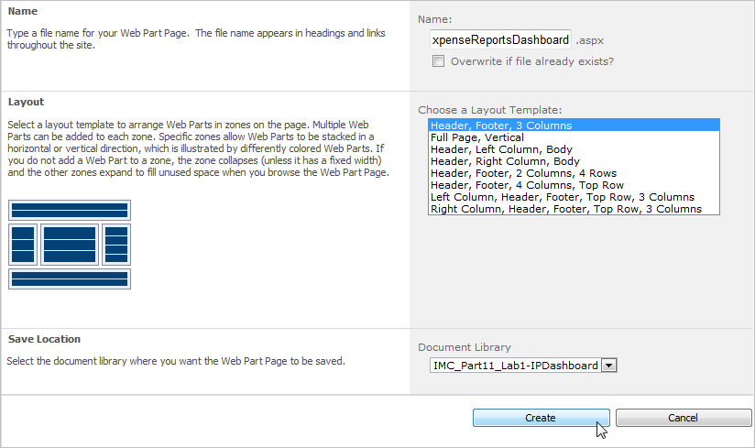
- When the new page opens, click Add a Web Part – let’s add it to the header.
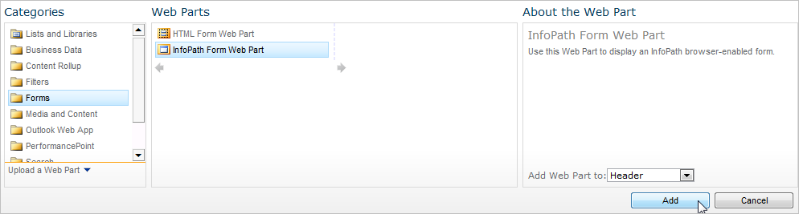
- Click on the link that says ‘Click here to open the tool pane’.
- Edit the Web Part.
  - In theList or Library dropdown, select the library where you published your Dashboard form to.
  - The Content Type dropdown should default to the form published in your selected library; but if you published your form as a content type and have configured your library to use it, then the Content Type dropdown should default to that; if not, select the correct one.
  - Uncheck the box that says “Send data to connected Web Parts when the page loads – we won’t be doing this.

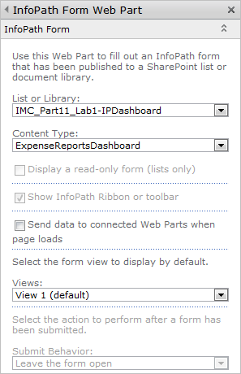
  - Expand the Appearance section – under Chrome Type, select None so we’d only see the form in the page, i.e. no title, no border.
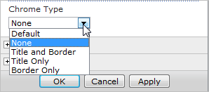
  - When done, click OK.
- Finally, click Stop Editing from the page ribbon.
Test the status indicators by submitting and/or editing forms from your Expense Reports library. The rows in the Dashboard should then be shaded depending on how long you have submitted forms.
---- End of Lab 1 ---

