How to use the SiteScanner App

- Login to the site where you have the SiteScanner App installed
- Go to Site Contents
- Select the SiteScanner App

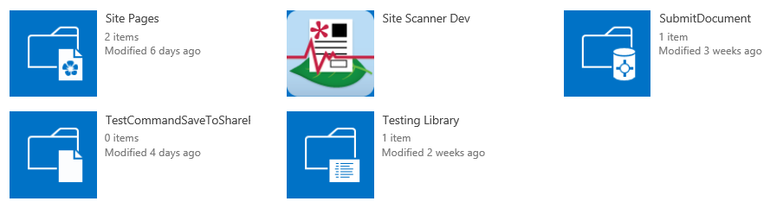
- The SiteScanner app page loads and you should see all the available Content Type, libraries and lists with InfoPath forms
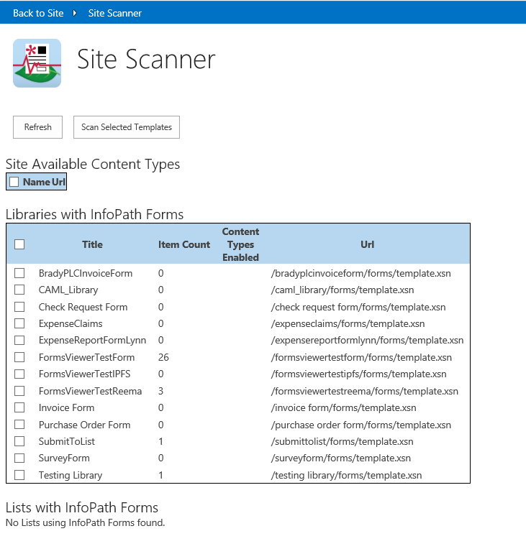
- Select the InfoPath form template that you want to scan and click the Scan Selected Templates button
- The scanner app will scan the form template and show the scan results in a new window

