SiteScanner app Installation

Installing the SiteScanner App – client site install

- Locate the downloaded zip file and un-zip.
- Navigate to your SharePoint Central Admin, and select apps > Manage App Catelog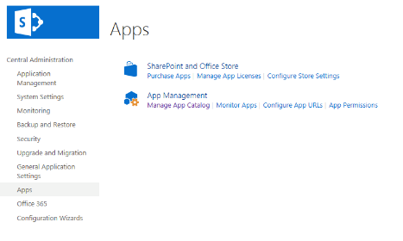
- Once you have navigated to your App Catalog select the Apps for SharePoint option from the side menu.
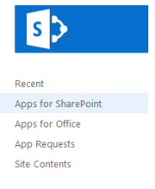
- Select the + New App button and browse to the .app file to upload.
- Once your file has uploaded it will be available in your site collection as an app.

Installing the SiteScanner App – dev Site install

- Locate the downloaded zip file and un-zip.
- Navigate to your SharePoint Admin center, and select apps > App CatalogDev Site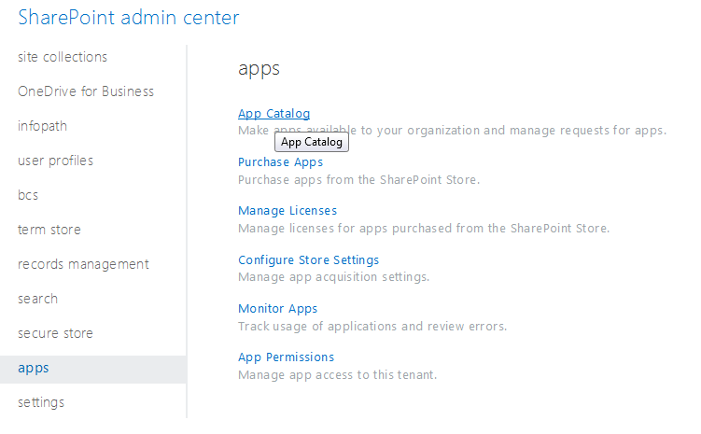
- Once you have navigated to your App Catalog select the Apps for SharePoint option from the side menu.
- Select the + New App button and browse to the .app file to upload.
- Once your file has uploaded, the FormsViewer will be available in your site collection as an app.

Installing the app on a site

- Navigate to the site where you would like to install the app.
- Select Site Contents > add an app
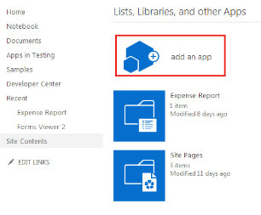
- You will see that the Forms Viewer is now an option for apps you can add. Select the Forms viewer and click trust when prompted. 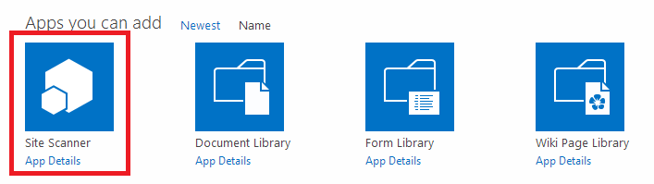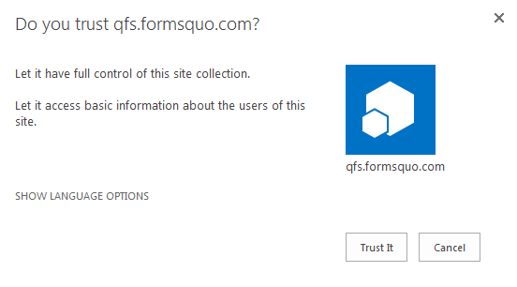

- Now your app is available for use on your SharePoint site.

