Set the following Rule:
- Set a fields value(queryFields->DCity) to the value from the dropdown:
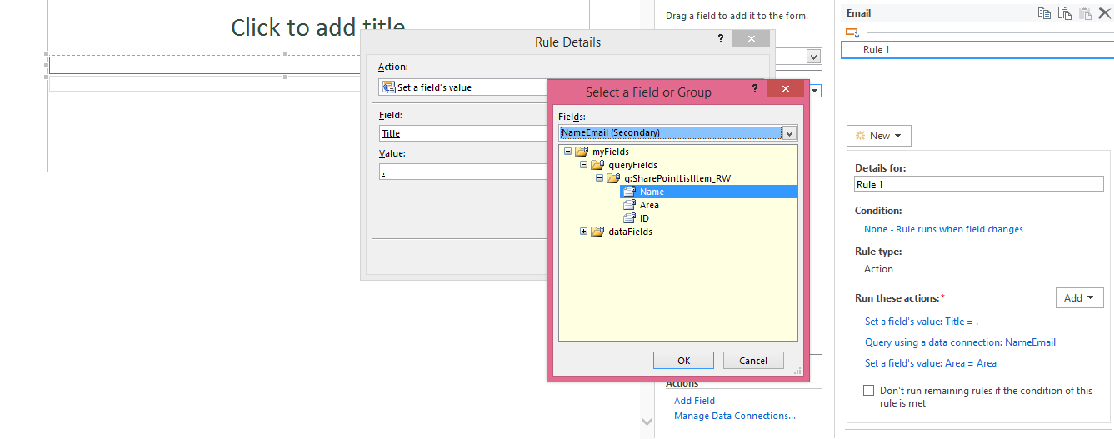
- Query the secondary Data Source
- Set the 3 single line text fields value to value from the secondary data source

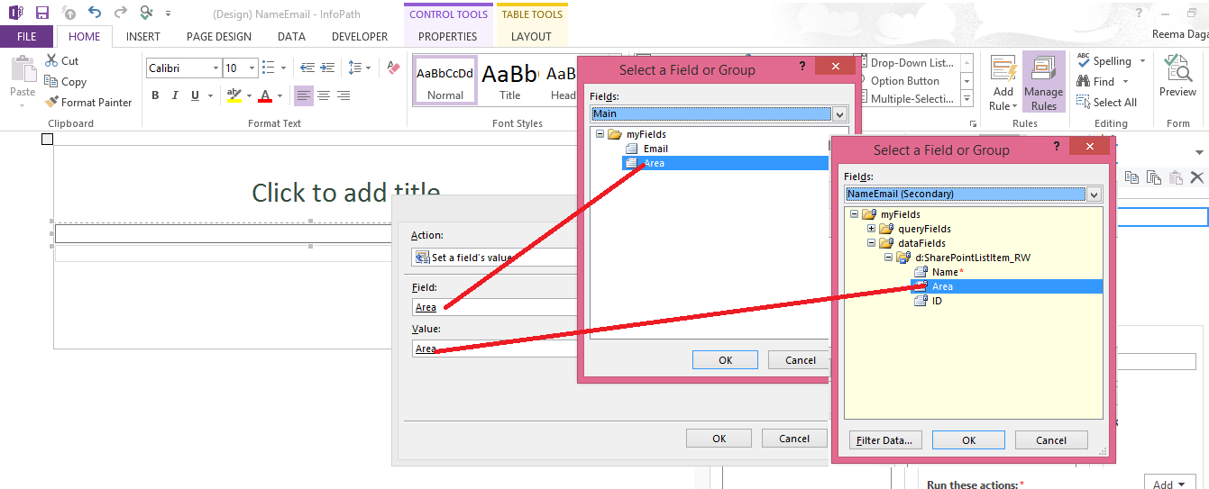

- Your rule should look like this:
