Set the following Rule:
- Set a fields value(queryFields->Name) to the value from the dropdown:
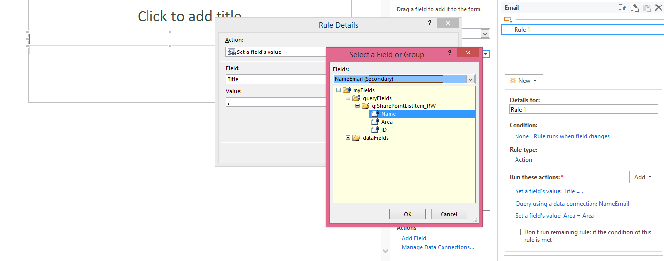
- Query the secondary Data Source
- Set the area fields value to value from the secondary data source

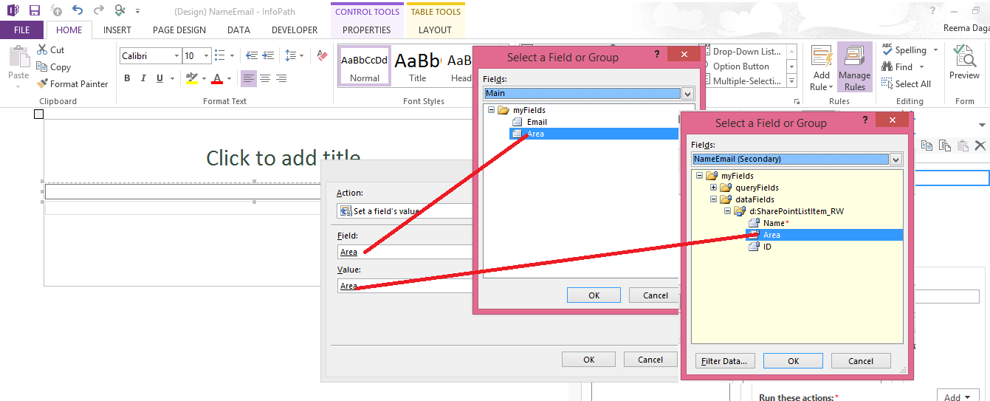

- Your rule should look like this:
